A Project Report on

**Empowering The Future: A Literacy Rate Analysis For A Better Future Tomorrow**

-

**Team ID :** 1A3DE5CEB373192AAE34FA734F5F087C

**Team Size :** 4

**Team Leader :** Monisha B -1A3DE5CEB373192AAE34FA734F5F087C

**Team member :** Viswa R -279F91234695B0CB94346585B3C81551

**Team member :** Sugumar G-F2604E7999A6650BE9A44920BBD29833

**Team member :** Moulidharan SR-566B09D7AD1DEA3A6CD4CB4CA4317016

**Project Mentor :**  Mrs Monisha

**Objective:**

To know development in a society, Literacy is another proper indicator of economic development. For purpose of census, a person in age limit of seven and above, who can both write and read with understanding in any of the language is considered as a literate in India. Literacy plays a major role in the economic development of a nation. Although India has raised its current literacy rate of 74.04% (2021) from 12% at the time of Independence in 1947, its still lag behind the world average literacy rate of 84%. Compared with other nations, Republic of India has the largest illiterate population.

|  |  |
| --- | --- |
| India Literacy Rate (According to 2011 Census) | |
| Overall | 74.04% |
| Male | 82.14% |
| Female | 65.46% |

Majority of states in India has shown majors signs of improvement in their overall illiteracy rate thus contributing towards a literate nation. Here we are analysing literacy rate in India for 2021. This dataset contains a record Literacy rate each state of India, here we are going to analyse State wise, Region wise and Overall Literacy rate among Children, Women and Men in India in India.

**Technical Architecture:**

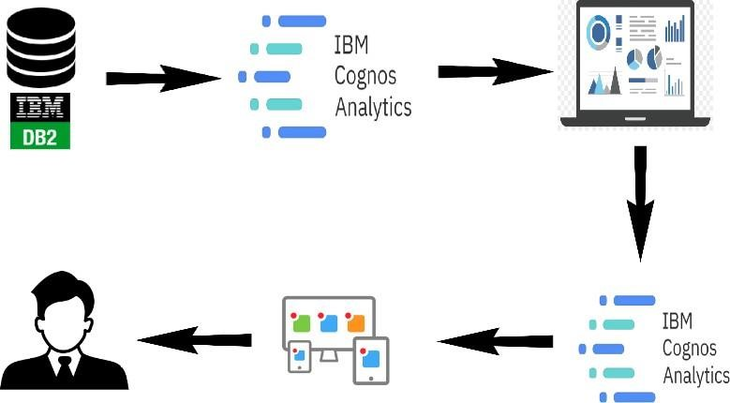

**Problem Understanding:**

Analyzing literacy rate is crucial for various reasons, as it provides valuable insights into the educational landscape and social development of a population or region. Literacy rate analysis helps assess the effectiveness of educational systems and policies. It allows policymakers and educators to identify strengths and weaknesses in the education system and make data-driven decisions to improve it. Monitoring Progress: Regular analysis of literacy rates allows for monitoring progress over time. It helps measure the impact of various initiatives and interventions, allowing stakeholders to adjust their strategies if needed.

**Business Requirements:**

**Workforce Productivity:** In a business setting, low literacy levels among employees can hinder productivity. Employees with limited literacy skills may struggle to understand written instructions, safety protocols, or training materials, leading to errors, accidents, and inefficiencies in the workplace.

**Online Business and E-commerce:** In the digital age, businesses heavily rely on online platforms for sales and communication. Low literacy rates can impact online engagement, e- commerce transactions, and customer support interactions.

**Training and Development:** Employee training and professional development are critical for a company's growth. Limited literacy skills can impede the effectiveness of training programs

**Business Expansion and Global Markets:** Companies aiming to expand into new markets or operate internationally need to understand the literacy levels and communication preferences of their target audiences in different regions.

**Literature Survey:**

**Demographic Information**:

1. Age: [ ] years
2. Gender: [ ] Male [ ] Female [ ] Non-binary [ ] Prefer not to say
3. Educational Background: o No formal education o Some primary education o Completed primary education o Some secondary education o Completed secondary education o Vocational training o Some college/tertiary education o Completed college/tertiary education o Graduate or post-graduate degree **Literacy Assessment:**
4. Can you read and understand a simple sentence in your native language? o Yes o No
5. Can you write a simple sentence in your native language? o Yes o No
6. How confident do you feel in your ability to read and understand complex written materials (e.g., newspapers, official documents)?

o Very confident o Confident o Neutral o Not confident o Not at all confident

**Social or Business Impact:**

**Social Impact**: It have a significant social impact, including the empowerment of individuals, improved social inclusion, poverty reduction, improved health outcomes, and promotion of gender equality

**Business Model/Impact**: It have a Businesses that invest in literacy programs and support education initiatives can benefit from a more skilled and innovative workforce, improved competitiveness, and enhanced social responsibility.

**Education Equity:** It helps identify disparities in educational opportunities and access to quality education across different demographic groups. This information can guide policymakers and educators in implementing targeted interventions to promote education equity, ensuring that all individuals have equal opportunities to learn and improve their literacy skills.

**Poverty Reduction:** Literacy is a key driver of economic empowerment. Higher literacy rates enable individuals to access better job opportunities, leading to increased income and poverty reduction. Analyzing literacy rates can inform poverty alleviation strategies and social programs aimed at improving livelihoods.

**Empowerment and Inclusion:** Literate individuals are better equipped to participate in societal and political processes, express their opinions, and advocate for their rights. Increasing literacy rates empowers marginalized communities and promotes social inclusion and active citizenship.

**Data Collection & Extraction From Database:**

Data collection is the process of gathering and measuring information on variables of interest, in an established systematic fashion that enables one to answer stated research questions, test hypotheses, and evaluate outcomes and generate insights from the data.

**Collect the Dataset:**

We have collected the data from India_Updated Literacy 2021.csv for the anlaysis of literacy rate in India of the year 2021.

**Children age**

**Men**

**5 years who Women (age 15- Men (age 15-**

**(age**

**States/UTs Area attended pre- (age 15- 15-49) 49)more years of with 10 or 49)more years of with 10 or**

**primary 49) (%)**

**(%) schooling (%) schooling (%)**

**school**

India Urban 18.1 83 89.6 56.3 62.1

India Rural 12 65.9 81.5 33.7 43.7

India Total 13.6 71.5 84.4 41 50.2

Andaman and

Urban 0 86.6 89.3 59.7 59.4

Nicobar Islands

Andaman and

Rural

Nicobar Islands 33.7 85.6 94.7 47.6 47.7

Andaman and

Total

Nicobar Islands 42.6 86 92.5 52.5 52.3

Andhra Pradesh Urban 10.2 79 86.4 51.2 59.5

Andhra Pradesh Rural 9.8 63.8 76.3 34.3 42.5

Andhra Pradesh Total 9.9 68.6 79.5 39.6 47.9

Arunachal

Urban 8 84.7 92.1 55.4 64.1

Pradesh

Arunachal

Rural 5.5 71.6 85.6 36.2 45

Pradesh

Arunachal

Total 5.9 73.8 86.7 39.4 48.2

Pradesh

Assam Urban 4.1 87.5 92.6 49 53.2

Assam Rural 4.4 75.4 82.8 26.2 32.2

Assam Total 4.4 77.2 84.3 29.6 35.5

Bihar Urban 18.5 74.9 84 48 57.1

Bihar Rural 10.5 54.5 77 25.2 38.9

Bihar Total 11.5 57.8 78.5 28.8 42.8

Chandigarh Urban 6.4 83.1 94.8 59.9 64.5

Chandigarh Rural 0 -69.2 0 -30.8 0

Chandigarh Total 6.3 83 94.8 59.6 64.5

Chhattisgarh Urban 6.3 85.3 90.3 52.4 52.2

Chhattisgarh Rural 4.2 71.3 86.3 32.1 38.1

Chhattisgarh Total 4.6 74.6 87.3 36.9 41.5

Dadra and Nagar

Haveli and Urban 6.2 87.7 95.4 48.6 58.8

Daman and Diu

Dadra and Nagar

Haveli and Rural 1.3 67.9 91.6 24.2 40.7

Daman and Diu

Dadra and Nagar

Haveli and Total 3.7 77.3 93.4 35.8 49.4

Daman and Diu

Goa Urban 19.5 92.6 94.9 73 75

Goa Rural -18.2 93.4 98.5 69.3 79.4

Goa Total 19 93 96.3 71.5 76.6

Gujarat Urban 8.7 86.8 95.4 47.9 56.9

Gujarat Rural 5.8 69 87.5 23.6 36.9

Gujarat Total 6.9 76.5 90.9 33.8 45.6

Haryana Urban 8.1 87.4 94.5 60.1 65

Haryana Rural 7.4 78.8 93 44.1 60.8

Haryana Total 7.6 81.7 93.5 49.5 62.2

Himachal

Urban 12.3 95 91.7 79.8 78.7

Pradesh

Himachal

Pradesh Rural 3.4 91.2 95.4 63.8 70.1

Himachal

Total 4.6 91.7 94.9 65.9 71.3

Pradesh

Jammu and

Urban 4 84.3 91.8 65.1 73.8

Kashmir

Jammu and

Rural

Kashmir 0.9 74.7 91.4 46.2 66

Jammu and

Total

Kashmir 1.6 77.3 91.5 51.3 68.2

Jharkhand Urban 15.2 82.4 94.1 54.4 66.2

Jharkhand Rural 7.6 59.3 80.3 26.3 39.4

Jharkhand Total 9 65 84 33.2 46.6

Karnataka Urban 18.9 85.1 90.5 62.3 64.8

Karnataka Rural 16.3 71 87 42 50.6

Karnataka Total 17.3 76.7 88.5 50.2 56.5

Kerala Urban 33.1 99.1 99.2 78.8 76.8

Kerala Rural 25.6 97.5 97.4 75.3 70.2

Kerala Total 29 98.3 98.2 77 73.3

Ladakh Urban 0 77.7 91.9 53.8 64.1

Ladakh Rural 0 76.6 94.2 49.2 74.8

Ladakh Total 0.7 76.8 93.7 50 72.7

Lakshadweep Urban 37.4 96.4 100 68.2 84.9

Lakshadweep Rural 0 96.8 -96.3 66.3 -69.4

Lakshadweep Total 32 96.5 99.1 67.8 80.9

Madhya Pradesh Urban 15.2 83.3 92.3 49.1 53.1

Madhya Pradesh Rural 9 63.3 82.6 21.7 35

Madhya Pradesh Total 10.5 68.9 85.3 29.3 39.9

Maharashtra Urban 29.9 90.2 94.6 61.1 68.3

Maharashtra Rural 27.3 79.5 91.5 40.7 54.3

Maharashtra Total 28.4 84.6 93 50.4 61

Manipur Urban 31.3 92.1 96.9 60 66.9

Manipur Rural 21.8 84.8 94 40.6 52.7

Manipur Total 25 87.6 95.2 48.1 58.7

Meghalaya Urban 36.3 97.1 92.9 61.4 63.9

Meghalaya Rural 30.3 85.5 81.5 27.3 27.7

Meghalaya Total 31.2 88.2 83.7 35.1 34.7

Mizoram Urban 6.9 99.1 99.2 62.3 59.1

Mizoram Rural 3.2 87.7 94.2 32.7 35.9

Mizoram Total 5 94.4 97.1 50 49.1

Nagaland Urban 5.5 91.5 97.7 63.7 75.6

Nagaland Rural 6.3 82.7 90.7 34.1 39.8

Nagaland Total 6.1 85.8 93.3 44.4 53.1

NCT of Delhi Urban 16 84.9 92.2 59.5 60.7

NCT of Delhi Rural -9.4 89 -93.5 68.7 -70.1

NCT of Delhi Total 15.8 85 92.3 59.7 60.9

Odisha Urban 8.5 83.9 90.7 47.9 46

Odisha Rural 11.2 69.2 86.1 29.6 36.6

Odisha Total 10.8 71.9 87.1 33 38.6

Puducherry Urban 24.5 92.1 93.4 68.9 78

Puducherry Rural -21.4 89.1 97.5 57.8 64.5

Puducherry Total 23.6 91.1 94.6 65.4 74.2

Punjab Urban 5.3 83.7 91.3 62.4 62.9

Punjab Rural 9.2 80 88.9 52.2 55.7

Punjab Total 7.8 81.4 89.9 56 58.7

Rajasthan Urban 12.3 81.3 92.5 51.2 62.2

Rajasthan Rural 8 61.6 90.1 27.8 48.4

Rajasthan Total 8.9 66.4 90.7 33.4 51.9

Sikkim Urban 0 92.8 96.9 60.2 70.7

Sikkim Rural 41.6 86.2 90.3 41.2 44.2

Sikkim Total 41.2 88.9 93 49 55

Tamil Nadu Urban 31.4 90.6 94.2 63.7 64.4

Tamil Nadu Rural 19.9 81.5 92.6 49.9 54.3

Tamil Nadu Total 25.2 85.9 93.4 56.6 59.1

Telangana Urban 16.7 81 90.2 60.9 71

Telangana Rural 14.3 58.1 81.3 36.3 54.6

Telangana Total 15.3 66.6 84.8 45.5 61.2

Tripura Urban 29.8 89.9 93.5 36.6 39.7

Tripura Rural 22.1 76.9 86 17.9 25.1

Tripura Total 24.2 80.6 88.2 23.2 29.4

Uttar Pradesh Urban 11.9 78.6 88 51.9 56.8

Uttar Pradesh Rural 8.6 65.6 86.3 35 45.6

Uttar Pradesh Total 9.3 68.8 86.7 39.3 48.6

Uttarakhand Urban 35.8 85.3 92.4 59.4 62.2

Uttarakhand Rural 32.2 79.8 93.2 46 58.7

Uttarakhand Total 33.2 81.6 92.9 50.4 59.8

West Bengal Urban 20.8 83.4 89.8 47.6 51.4

West Bengal Rural 19.9 72.5 77.8 25.9 26.9

West Bengal Total 20.1 76.1 81.6 32.9 34.7

**Connect IBM DB2 with IBM Cognos:**

Successfully connected Db2 Database with IBM Cognos Analytics.

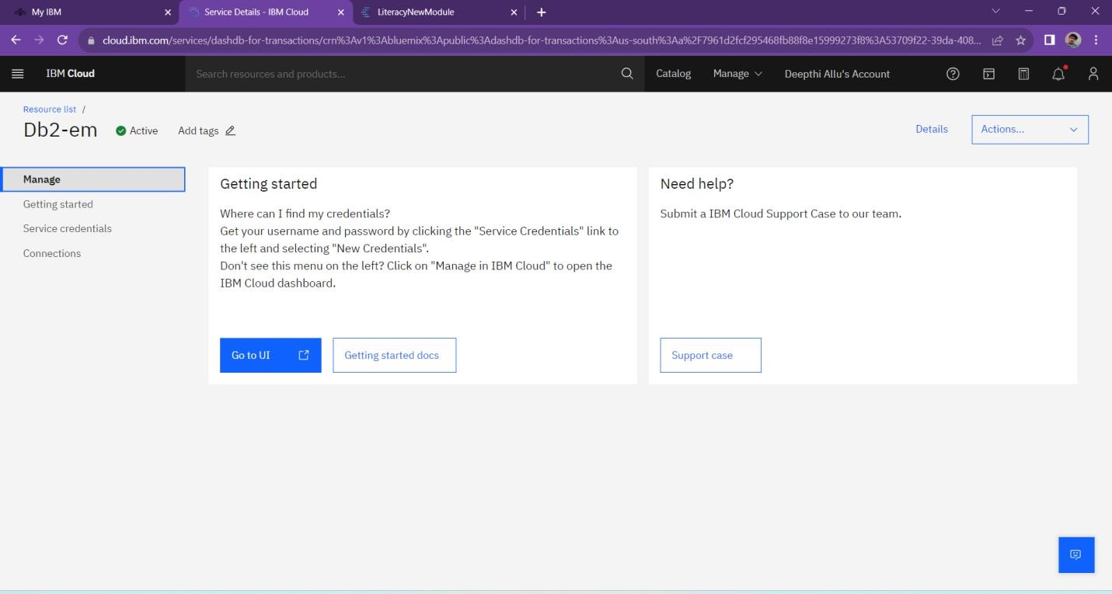

**Data Preparation:**

**Prepare The Data For Visualization:**

Data modules are containers that describe data and rules for combining and shaping data to prepare it for analysis and visualization in IBM Cognos Analytics. Data module sources. Data modules can be based on data servers, packages, uploaded files, data sets, and other data modules.

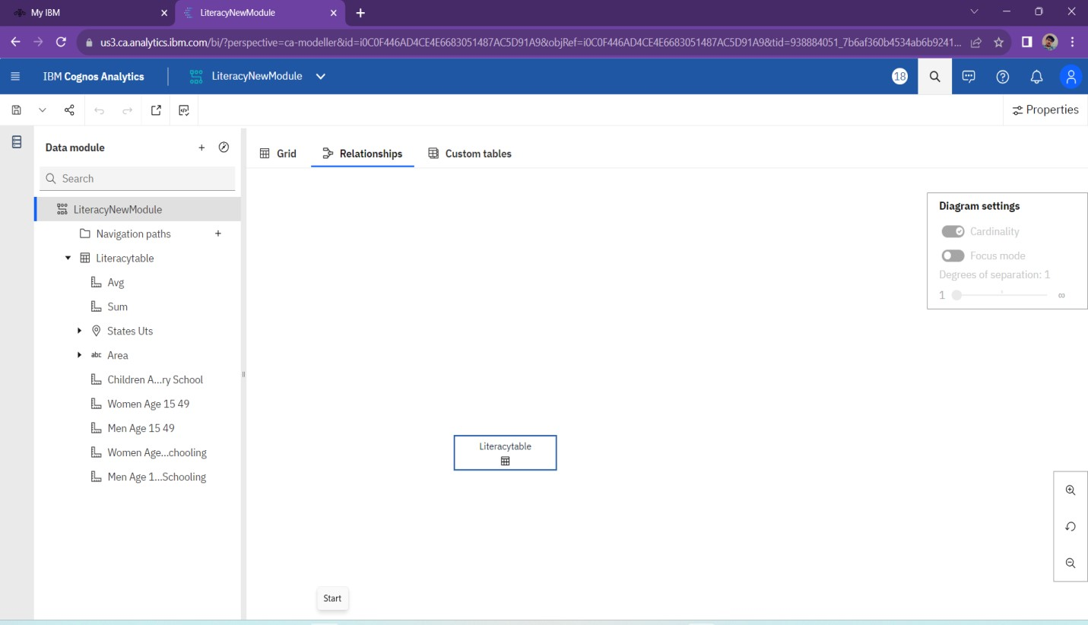

# Data Visualization

Data visualization is the process of creating graphical representations of data in order to help people understand and explore the information. The goal of data visualization is to make complex data sets more accessible, intuitive, and easier to interpret. By using visual elements such as charts, graphs, and maps, data visualizations can help people quickly identify patterns, trends, and outliers in the data.

**No of Unique Visualizations:**

The number of unique visualizations that can be created with a given dataset. Some common types of visualizations that can be used to analyze the literacy rate in India for the year 2021 include bar charts, line charts, heat maps, scatter plots, pie charts, Maps etc. These visualizations can be used to compare literacy rate in all states of India, literacy rate of Men and Women in Rural and Urban Areas of the states.Here are some unique visualizations from the dataset-

1.Overall Literacy Rate

2.Literacy Rate in Indian States

3.Literacy Rate of Women, Men and Children

4.Average Literacy Rate of Women, Men and Children

5.Top Literate States

6.Bottom Literate States

7.Women Literacy Rate in Rural and Urban Area

8.Men With Age Group 15-49 Over Those Who Attended Schooling 1.Overall Literacy Rate

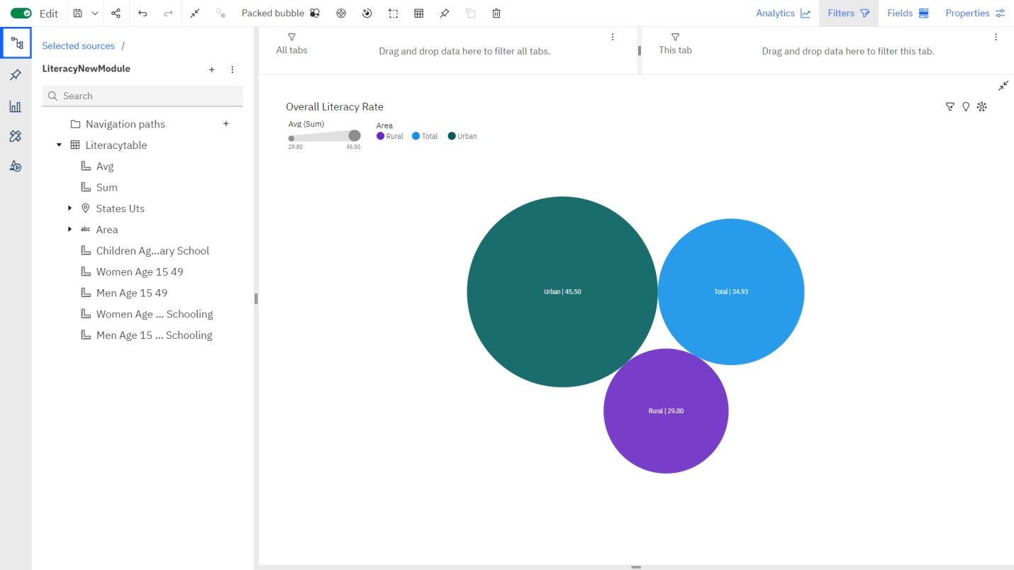

2.Literacy Rate in Indian States

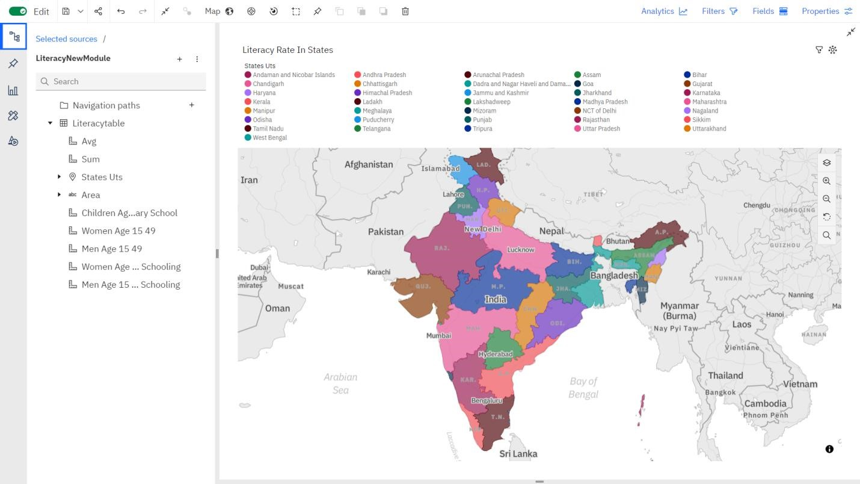

3.Literacy Rate of Women, Men and Children

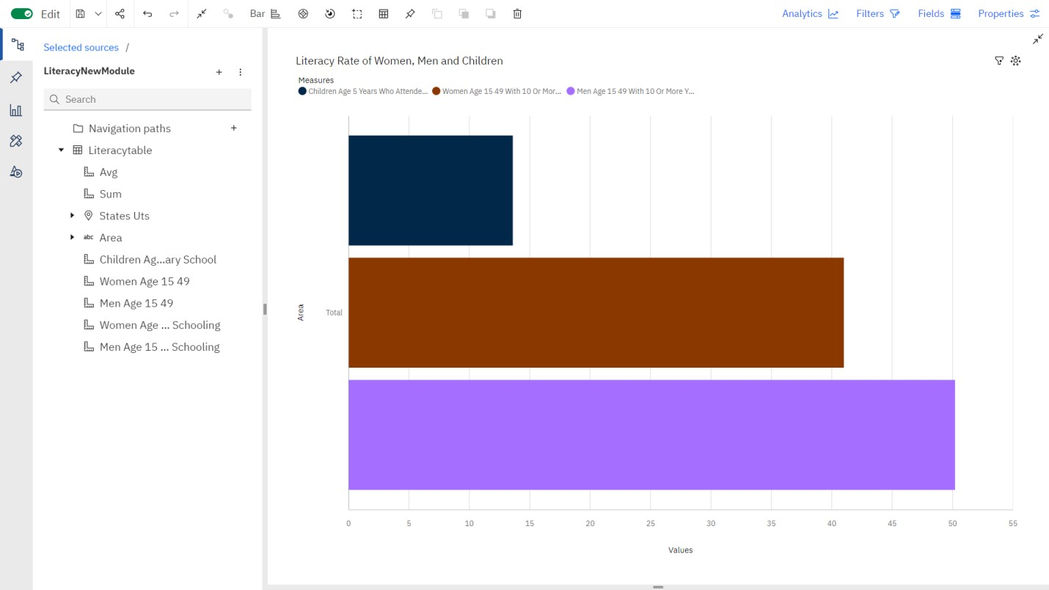

4.Average Literacy Rate of Women, Men and Children

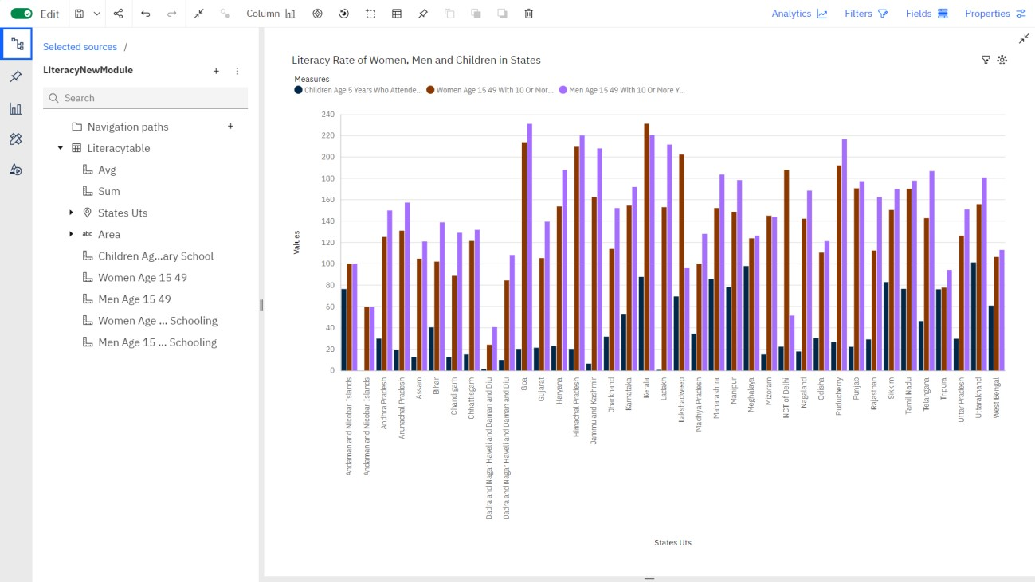

5.Top Literate States

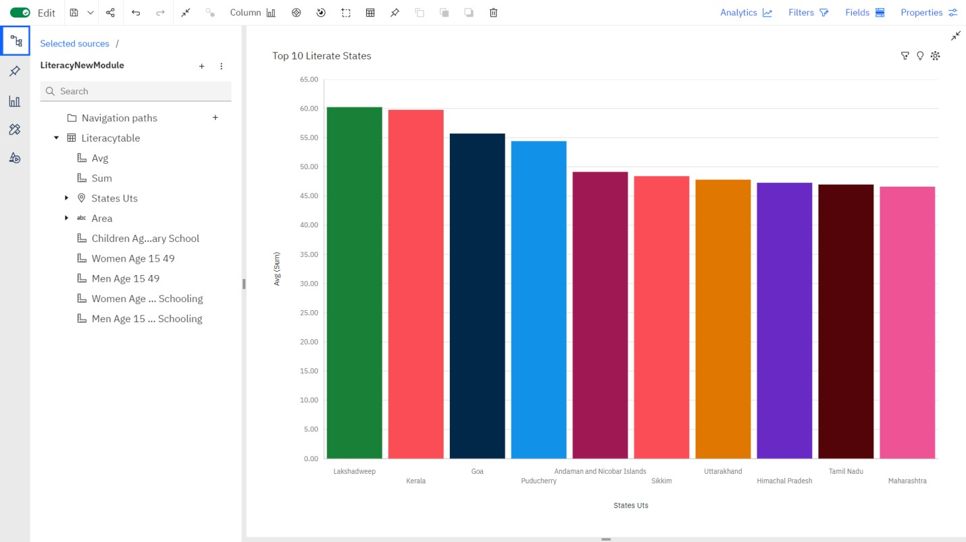

6.Bottom Literate States

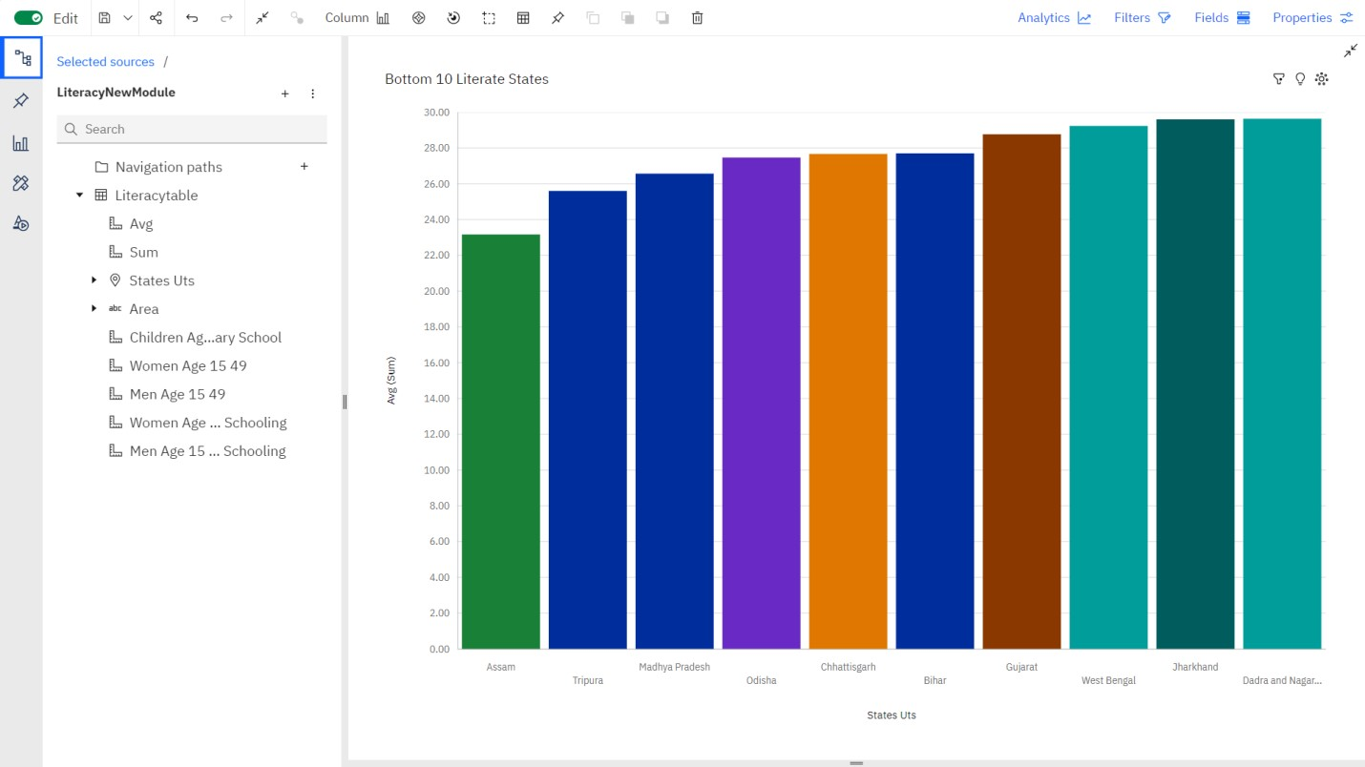

7.Women Literacy Rate in Rural and Urban Area

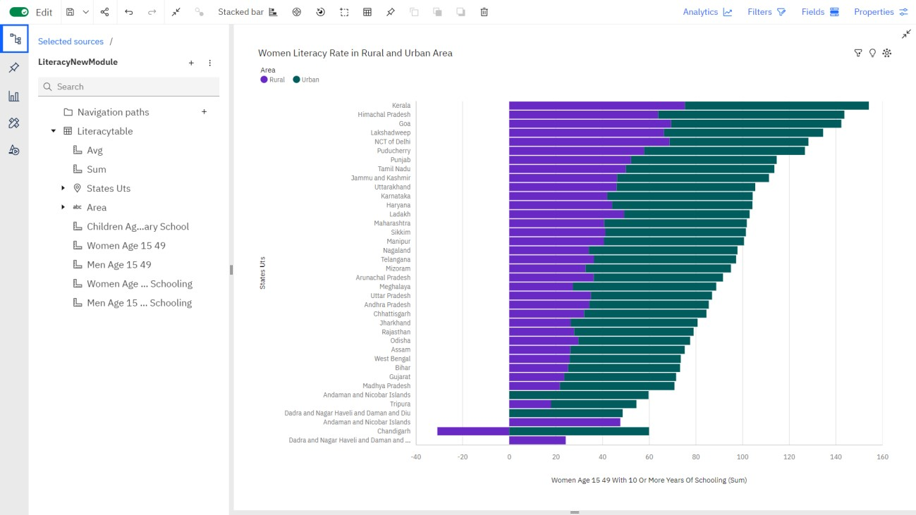

8.Men With Age Group 15-49 Over Those Who Attended Schooling

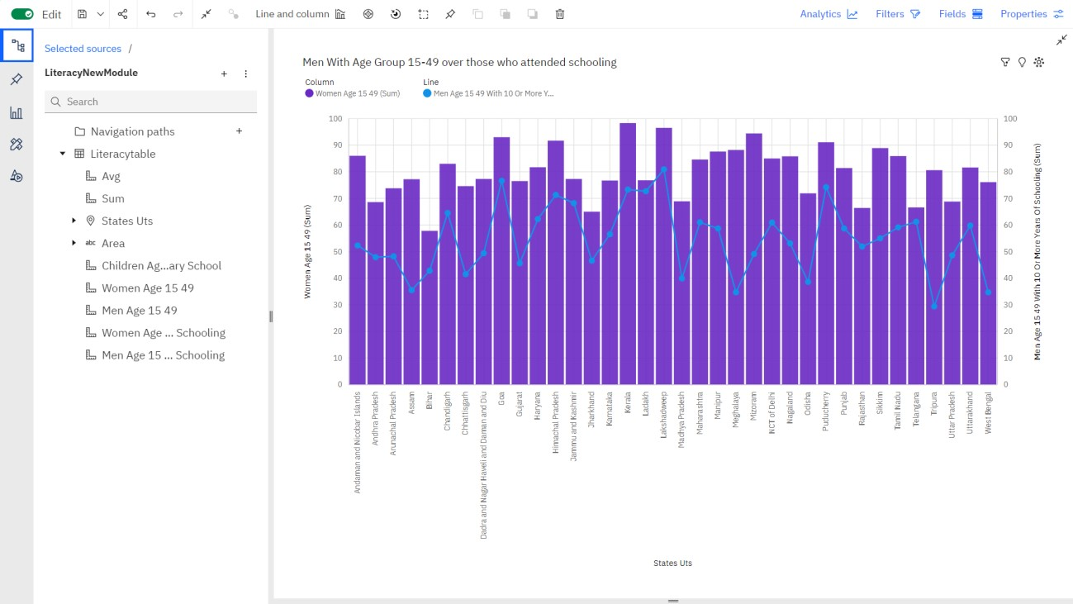

# Dashboard

A dashboard is a graphical user interface (GUI) that displays information and data in an organized, easy-to-read format. Dashboards are often used to provide realtime monitoring and analysis of data, and are typically designed for a specific purpose or use case. Dashboards can be used in a variety of settings, such as business, finance, manufacturing, healthcare, and many other industries. They can be used to track key performance indicators (KPIs), monitor performance metrics, and display data in the form of charts, graphs, and tables.

## Responsive and Design of Dashboard

The responsiveness and design of a dashboard for Data-Driven insights on Literacy rate is crucial to ensure that the information is easily understandable and actionable. Key considerations for designing a responsive and effective dashboard include user-cantered design, clear and concise information, interactivity, datadriven approach, accessibility, customization, and security. The goal is to create a dashboard that is user-friendly, interactive, and data-driven, providing actionable insights.

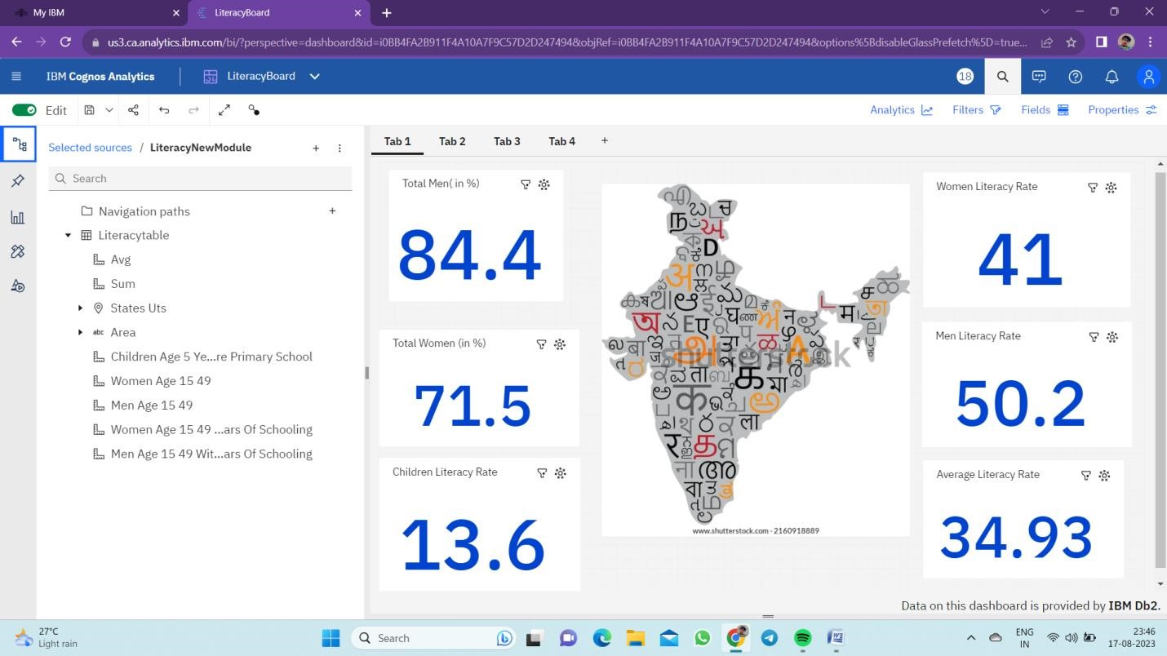

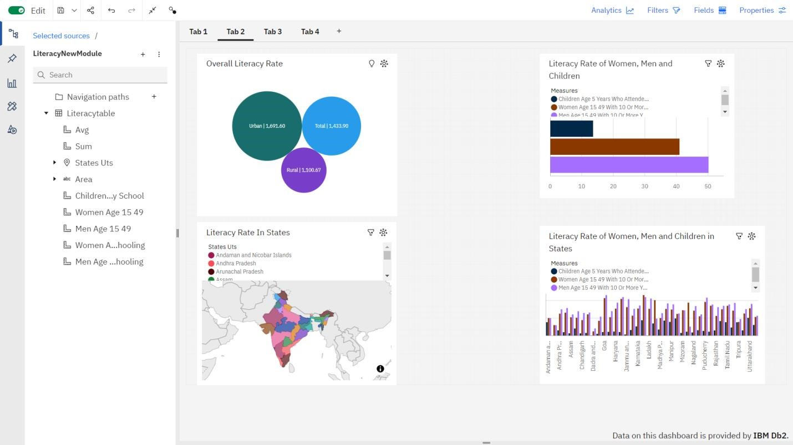

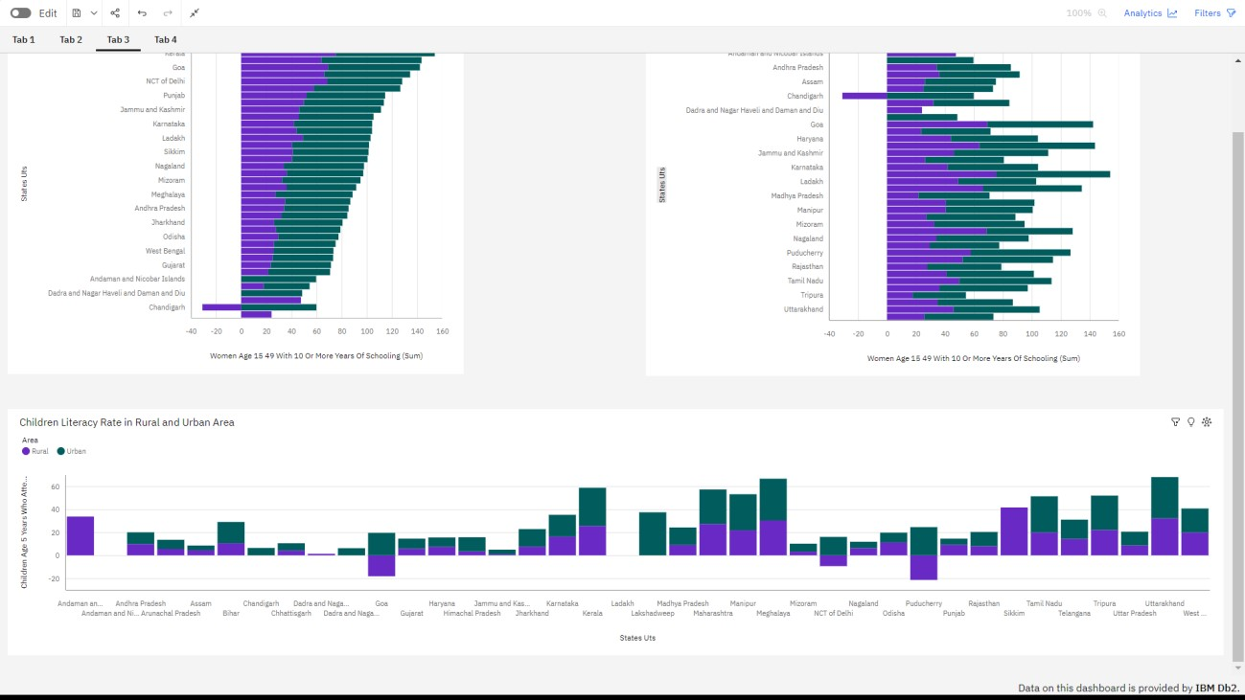

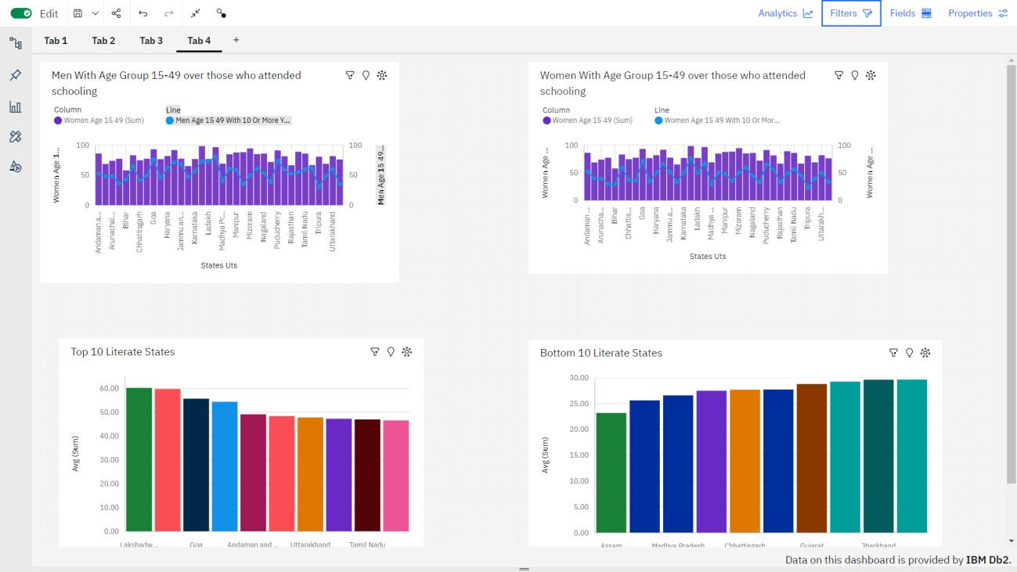

# Story

A data story is a way of presenting data and analysis in a narrative format, with the goal of making the information more engaging and easier to understand. A data story typically includes a clear introduction that sets the stage and explains the context for the data, a body that presents the data and analysis in a logical and systematic way, and a conclusion that summarizes the key findings and highlights their implications. Data stories can be told using a variety of mediums, such as reports, presentations, interactive visualizations, and videos.

## No of Scenes of Story

The number of scenes in a storyboard for Data-Driven insights on Literacy will depend on the complexity of the analysis and the specific insights that are trying to be conveyed. A storyboard is a visual representation of the data analysis process and it breaks down the analysis into a series of steps or scenes.

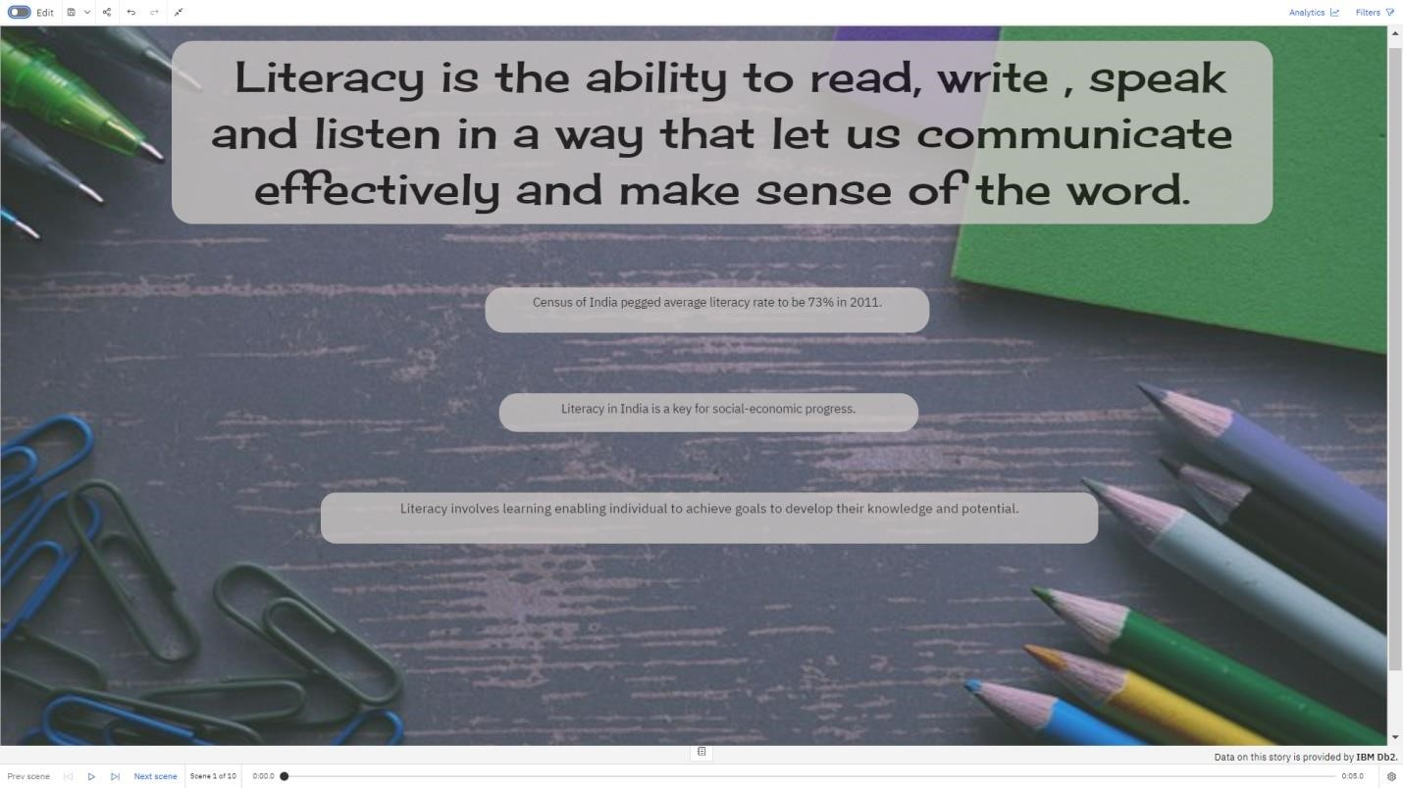

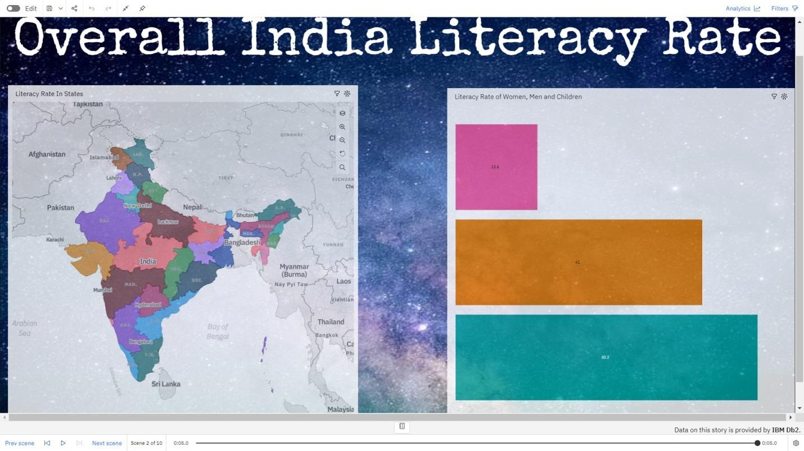

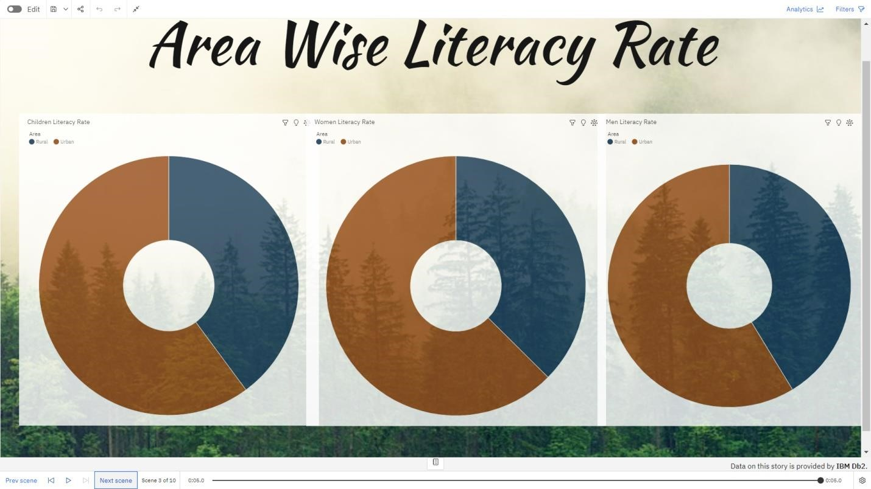

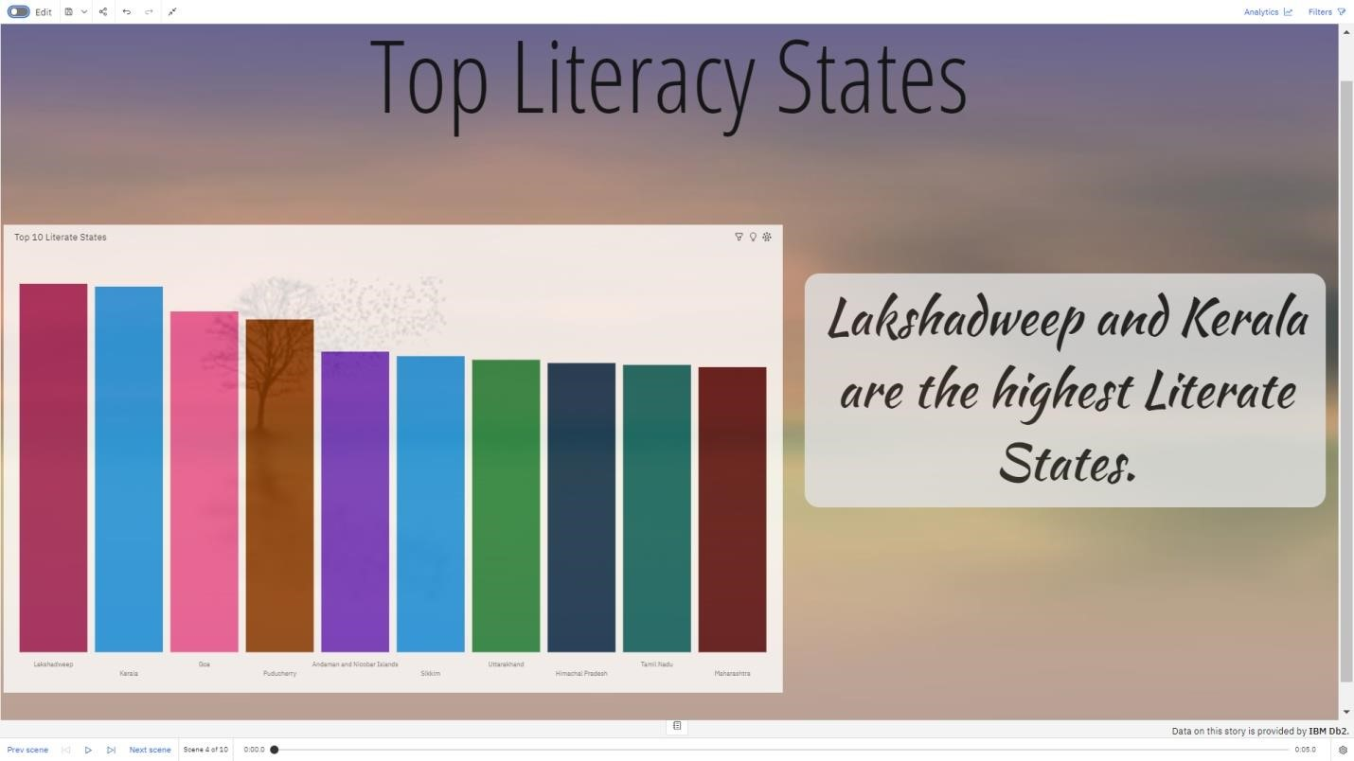

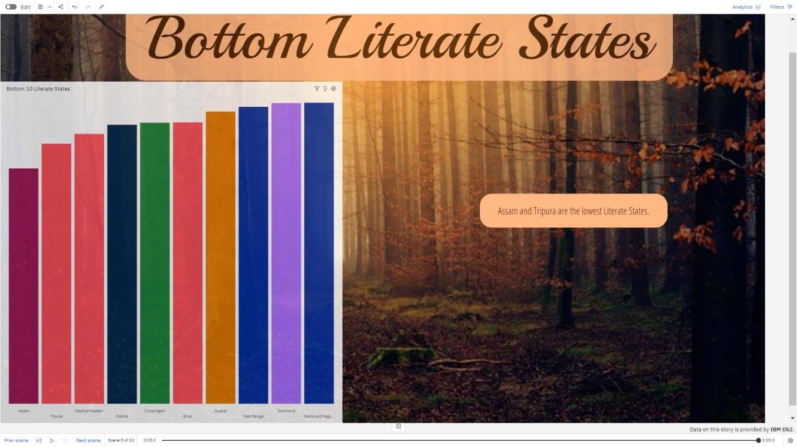

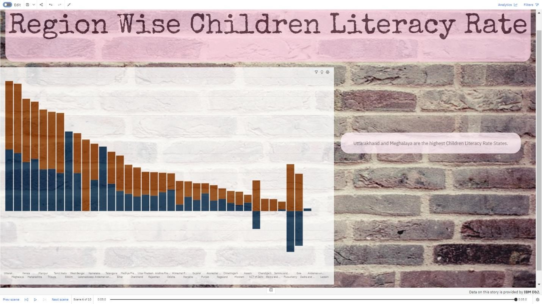

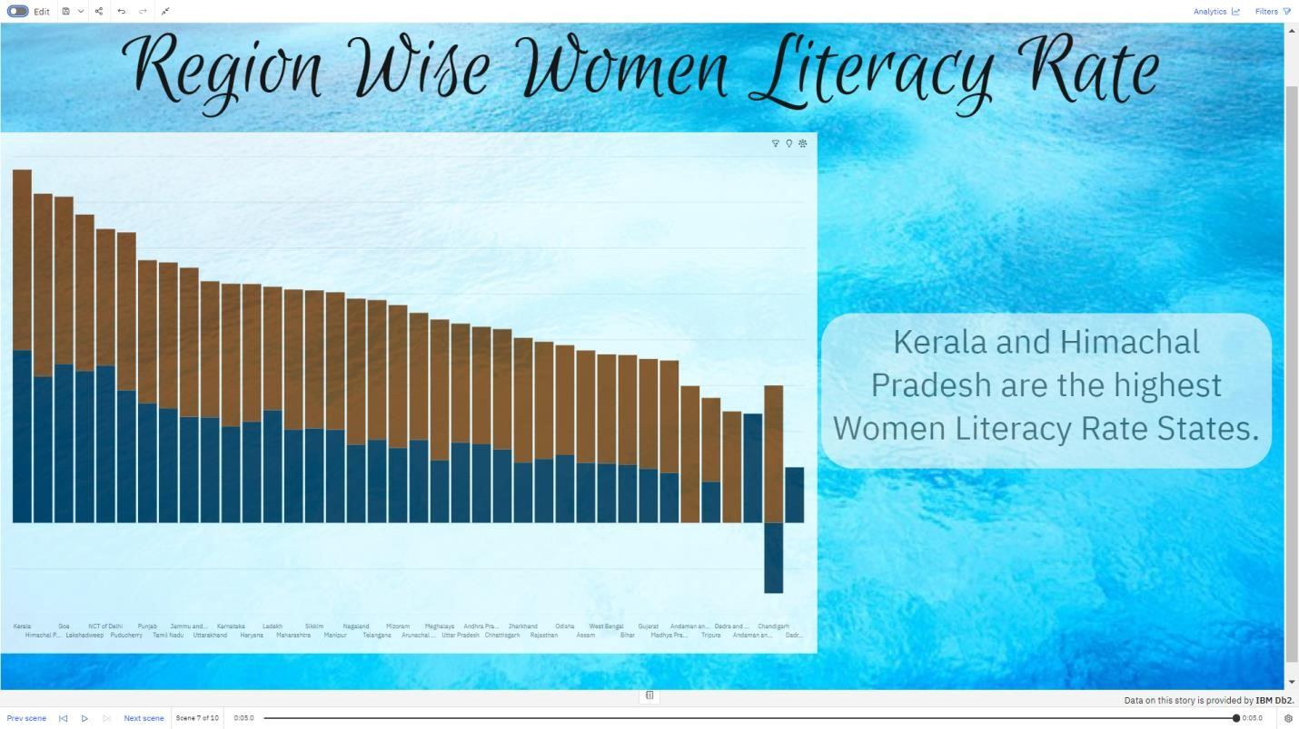

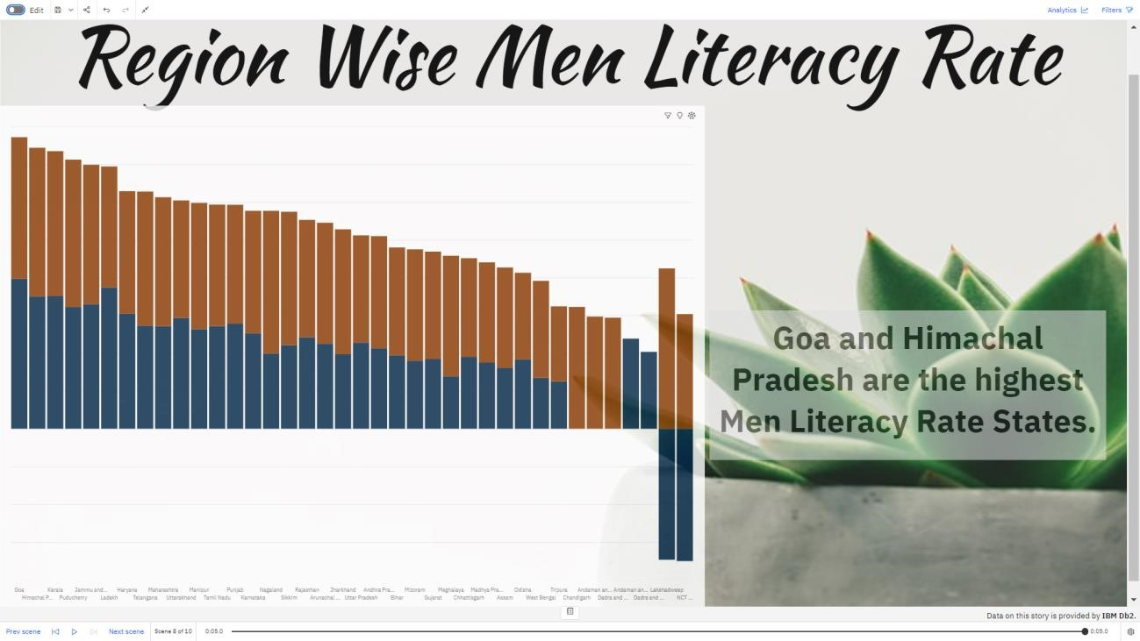

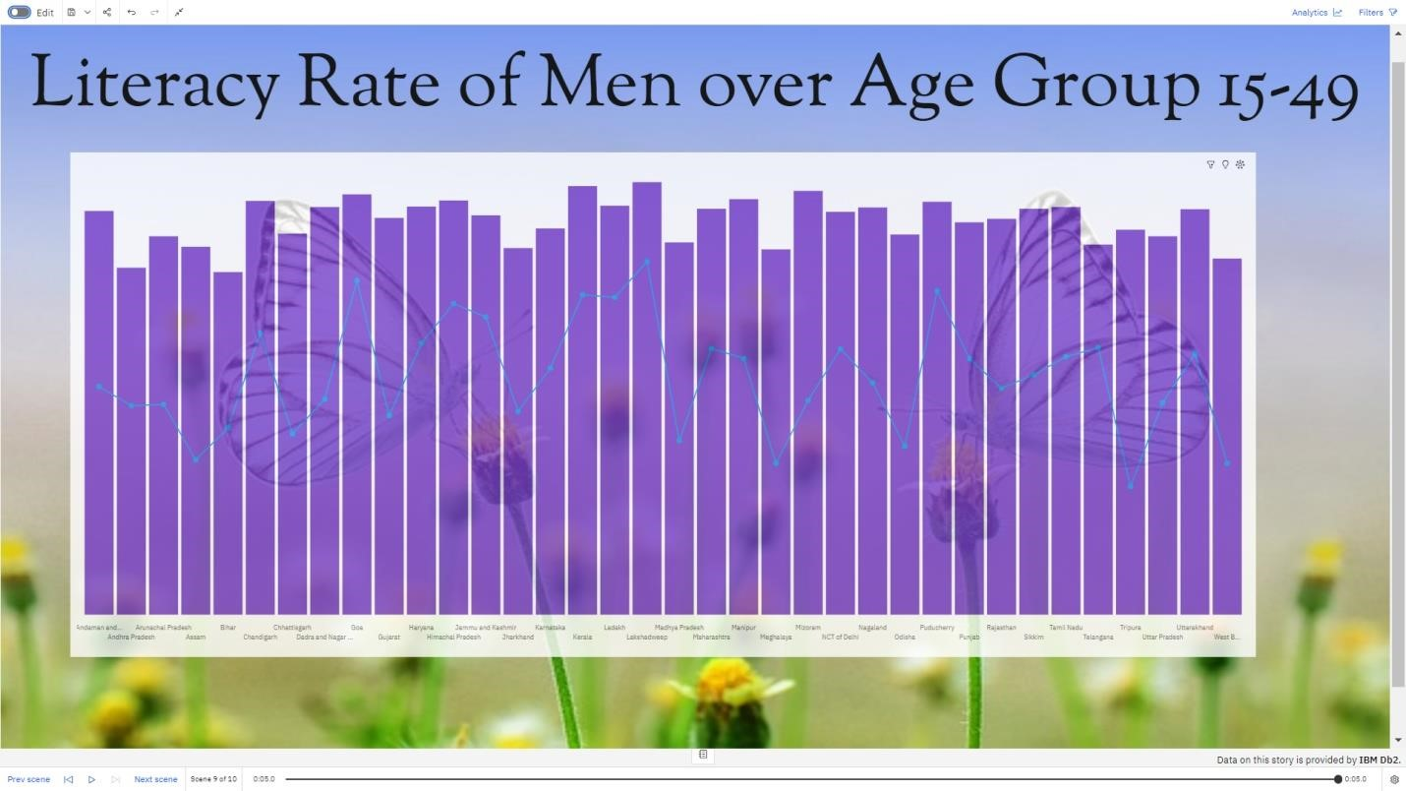

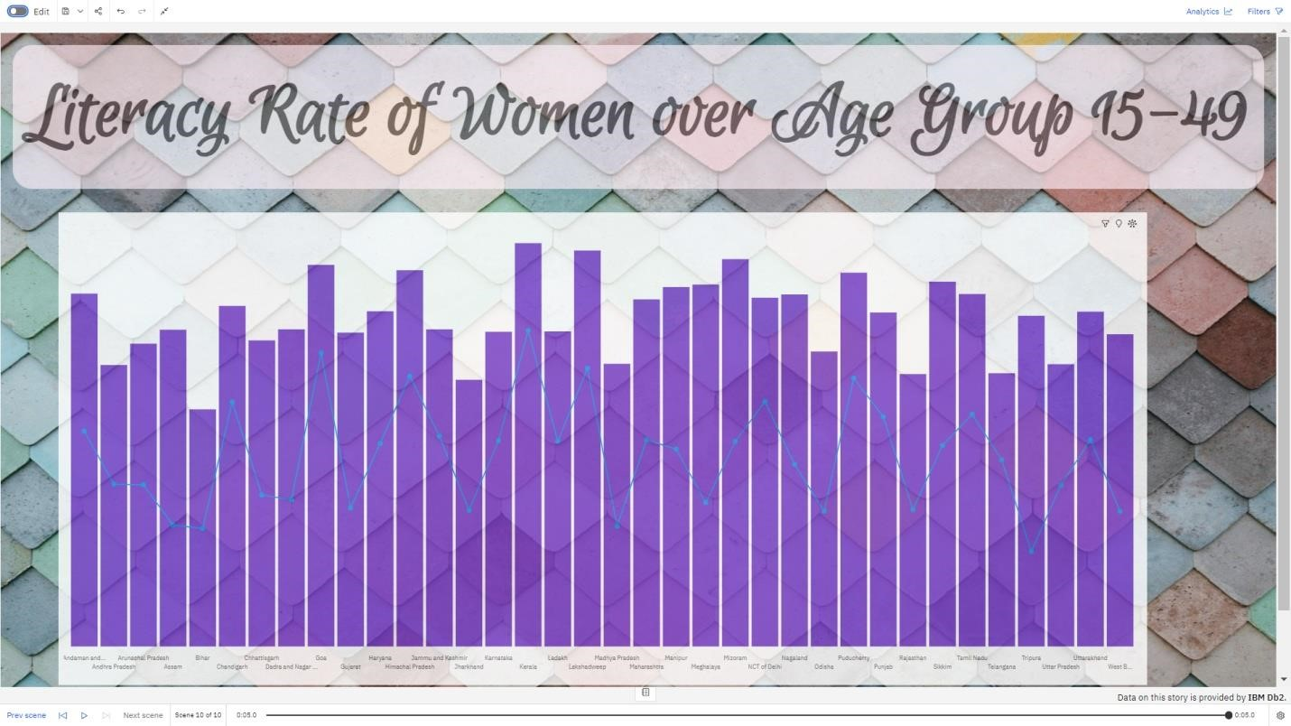

# Report

A report in data analytics typically involves analysing and interpreting data to draw insights and conclusions that can inform business decisions or address research questions. The report usually includes a summary of the data analysis process, including the methods and tools used, as well as the findings and recommendations based on the analysis. The report should begin with an executive summary, which provides a brief overview of the main findings and recommendations. The introduction should provide background information on the problem or research question being addressed and the data sources used.

## Creating Report

When creating a report in Cognos, it is often helpful to include visualizations to help communicate the findings of the analysis.

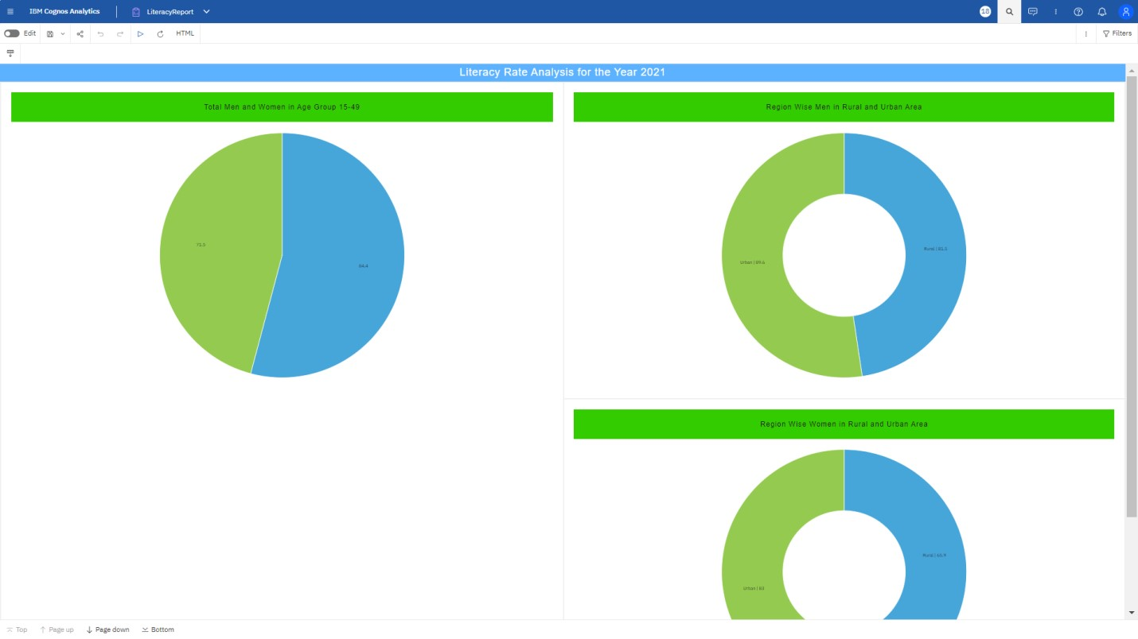

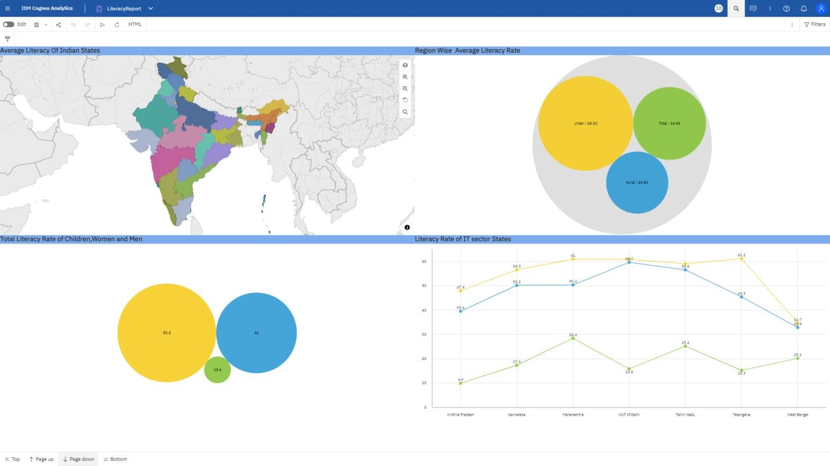

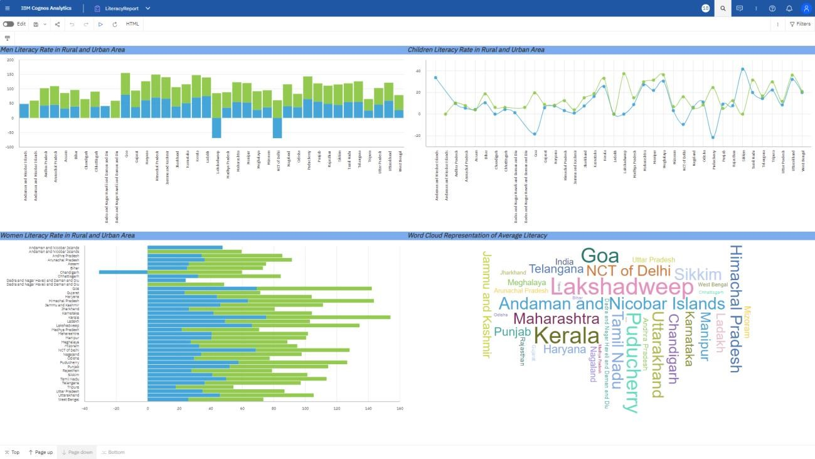

## Performance Testing

**Utilization Of Filters:**

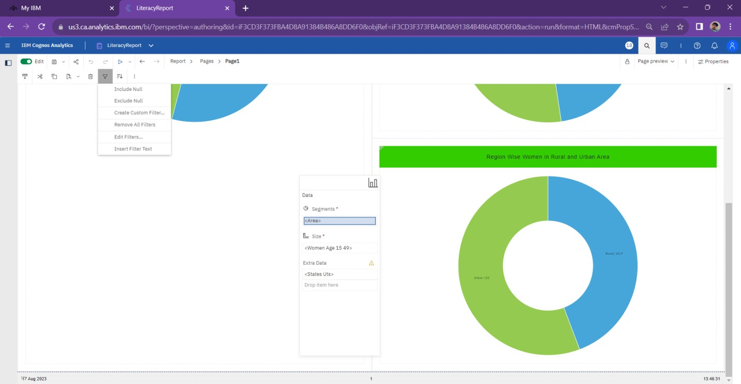

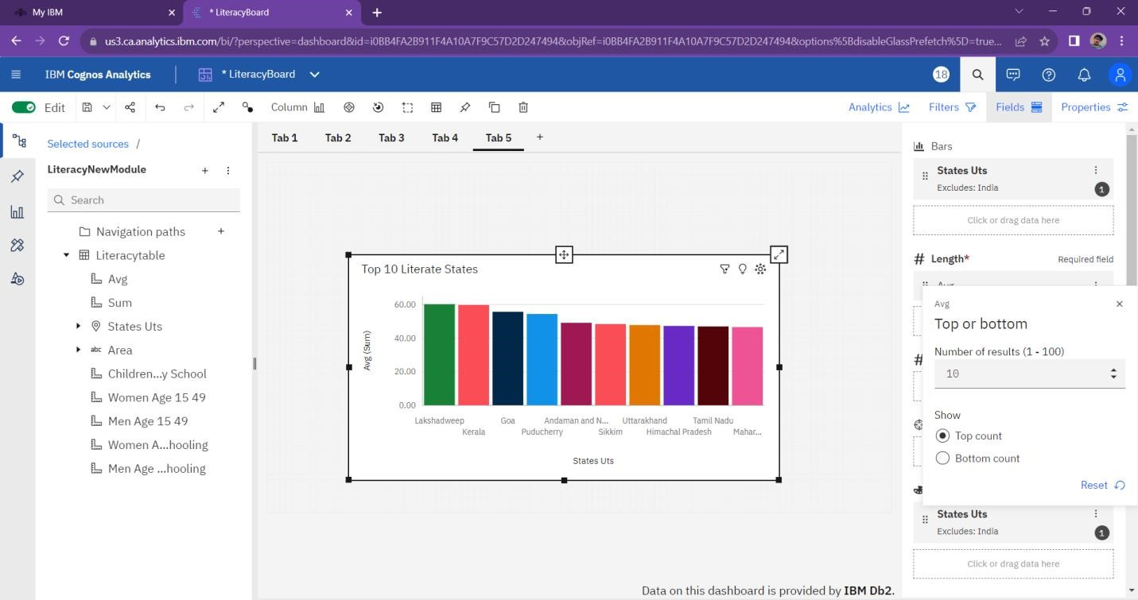

## No of Calculation Fields

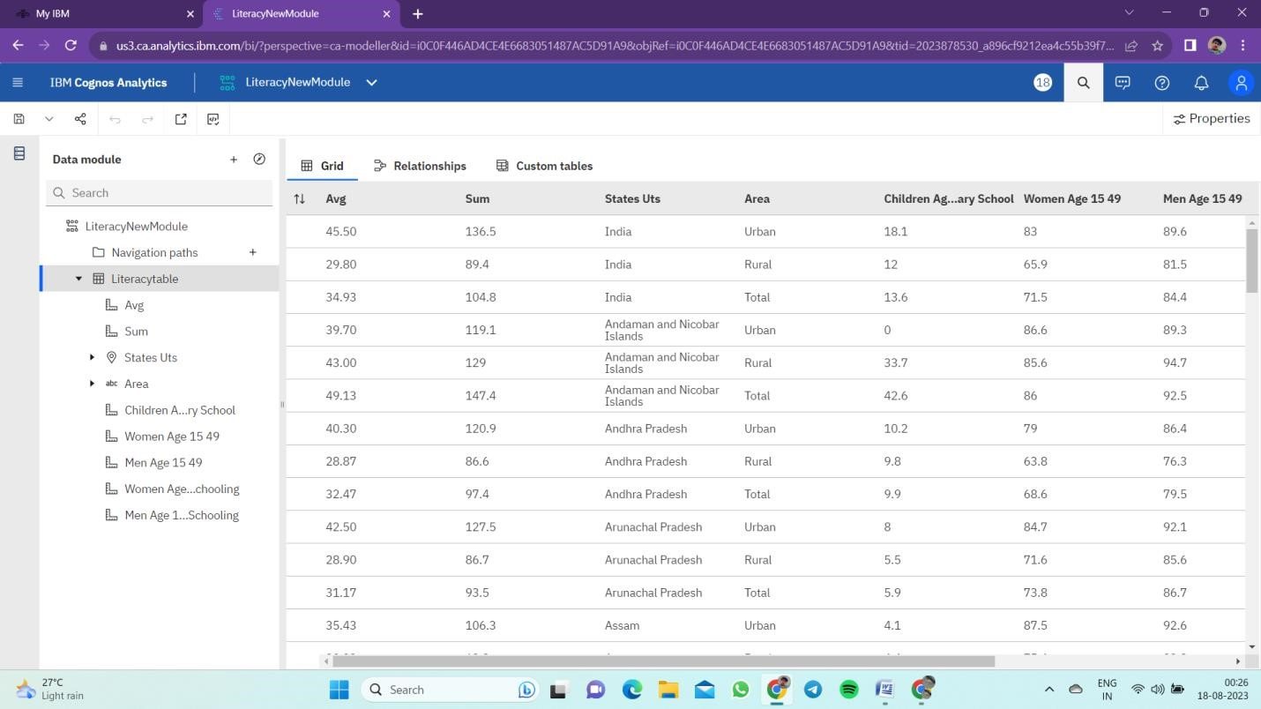

# No of Visualizations/ Graphs

* Overall Literacy Rate
* Literacy Rate in Indian States
* Literacy Rate of Women, Men and Children
* Average Literacy Rate of Women, Men and Children in States
* Top Literate States
* Bottom Literate States
* Women Literacy Rate in Rural and Urban Area
* Men with Age group 15-49 over those who attended schooling

# Web Integration

Publishing helps us to track and monitor key performance metrics, to communicate results and progress, help a publisher stay informed, make better decisions, and communicate their performance to others.

**RESULT:**

Empowering the future with a higher literacy rate can lead to a more analytically adept society, creating a better tomorrow through improved critical thinking, innovation, and informed decision-making. A literate population can better understand complex issues, engage in lifelong learning, and contribute to the growth of their communities and the world at large.

**ADVANTAGES:**

* Understanding the literacy rate in India can also businesses keep track of government policies and initiatives aimed at improving literacy rates.
* Businesses need to understand the literacy rates in India to conduct market research and determine the potential customer base for their products or services.
* **Enhanced Problem-Solving**: A literate and analytically skilled population can better identify and tackle complex problems, leading to improved socio-economic development.
* **Innovation and Creativity**: High literacy and analytical abilities foster creativity and innovation, encouraging individuals to come up with new ideas and solutions.
* The ultimate goal is to gain insights and improve performance through data visualization techniques.
* The literature survey for literacy rate analysis involves reviewing academic articles, and other sources related to the analytics of literacy rate.
* **Informed Decision-Making**: A well-informed society can make better decisions, both at the individual and societal levels, leading to more effective governance and policies.
* **Economic Growth:** Increased literacy and analytical skills can boost productivity, attract investments, and create a skilled workforce, contributing to economic growth
* **Reduced Poverty:** A literate population has better access to job opportunities, which can help alleviate poverty and improve the overall standard of living.
* The literacy rate analysis in India can help businesses make informed decision, improve their marketing efforts, plan their workforce, and contribute to social causes, among other benefits.

**DISADVANTAGES:**

* We have people with insufficient information, as well as those with disinformation, mixed in the group with those who simply want to provide the TRUTH about a subject of internet.
* Just knowing the truth and providing it to the public is to easy task when you are computing with such thick bias, such as what we have in society today.
* **Inequality:** Empowering only a portion of the population with literacy and analysis skills may lead to a knowledge gap, exacerbating socio-economic inequalities.
* **Educational Challenges**: Implementing and maintaining comprehensive literacy programs can be resource-intensive and may face obstacles in certain regions or communities.
* A lot of consumers don’t know who to believe, and some believe the wrong sources.
* **Resistance to Change:** Some individuals or communities might resist embracing new analytical methods or literacy initiatives due to cultural or social factor.
* **Technological Dependence:** Relying solely on analysis and technology may reduce critical thinking and creativity in problem-solving, potentially hindering adaptability.
* **Misuse of Information:** A highly literate and analytically skilled population could potentially misuse information for malicious purposes, emphasizing the need for ethical awareness.
* Overall, despite the potential challenges, promoting literacy and analysis can significantly contribute to a brighter and more prosperous future for tomorrow's society.
* It’s frustrating and annoying when you know the TRUTH, then meet others who are convinced of something false. It is often a waste of time even talking to them, nobody is so blind as one who not see.

**APPLICATIONS:**

* The applications of empowering the future through literacy rate analysis for a better tomorrow include:
* **Educational Policy and Planning**: Using literacy rate analysis, governments and organizations can identify regions or groups with low literacy rates and formulate targetedpolicies to improve access to quality education and resources.
* **Resource Allocation**: By understanding literacy trends, funds and resources can be allocated more efficiently to enhance educational infrastructure, teacher training, and learning materials in areas that need it the most.
* **Early Intervention Programs**: Literacy rate analysis can help identify children at risk of falling behind in their reading and writing skills. Early intervention programs can be designed to provide extra support and improve literacy outcomes.
* **Workforce Development**: Analysing literacy rates can help tailor vocational training programs to meet the demands of the job market, ensuring a skilled and competitive workforce.
* **Social and Economic Development**: Improved literacy rates lead to higher employability, increased earning potential, and greater participation in economic activities, contributing to overall social and economic development.
* **Empowerment of Marginalized Groups**: Literacy rate analysis can highlight disparities among different socioeconomic groups, empowering policymakers to implement targeted initiatives that address these disparities.
* **Digital Literacy Initiatives**: With technological advancements, digital literacy is crucial for future success. Analysing literacy rates can guide the development of digital literacy programs to ensure people are equipped with essential digital skills.
* **Health Literacy**: Understanding literacy rates can aid in designing health education programs that promote better health outcomes and preventive measures within communities.
* **Research and Data-Driven Decision Making**: Literacy rate analysis generates valuable data that researchers and policymakers can use to make informed decisions and track progress over time.
* **Global Development Initiatives**: International organizations can leverage literacy rate analysis to prioritize support for countries with low literacy rates, contributing to global efforts in achieving sustainable development goals.
* Overall, empowering the future through literacy rate analysis is a vital step towards building a more educated, informed, and equitable society for a better future.

**CONCLUSION:**

Empowering the future through improved literacy rates is essential for a better tomorrow. Higher literacy rates lead to a more educated and informed society, fostering economic growth, reducing poverty, and promoting social cohesion. Enhanced access to education and literacy programs can empower individuals to make better-informed decisions and contribute positively to their communities. Investing in education and promoting literacy is a crucial step towards creating a brighter and more equitable future for all.

**FUTURE SCOPE:**

The future scope of empowering the future through literacy analysis holds immense potential for creating a better tomorrow. Literacy is a crucial aspect of human development and has far-reaching impacts on various aspects of society, economy, and individual well-being. Here are some potential areas of future scope for leveraging literacy rate analysis:

* **Targeted Educational Interventions**: By analysing literacy rates at different levels (national, regional, or local), policymakers can identify areas with low literacy rates and design targeted educational interventions. This could include providing resources, funding, and support to improve educational infrastructure and access to quality education in underserved communities.

* **Early Childhood Education**: Focusing on early childhood education can significantly improve literacy rates in the long run. By understanding the literacy levels of young children and identifying potential barriers, educational programs and policies can be tailored to enhance early literacy skills and foster a love for learning from an early age.

* **Adult Literacy Programs**: A significant portion of the global population remains illiterate or has low literacy levels, particularly among adults. By analysing literacy rates in this demographic, governments and organizations can design and implement adult literacy programs to empower individuals, improve employability, and enhance their overall quality of life.

* **Digital Literacy**: With the increasing reliance on technology in all aspects of life, digital literacy is becoming a vital skill. Analysing literacy rates in relation to digital skills can help identify areas that need support in adapting to the digital era and ensure that individuals can participate fully in the digital economy.
* **Socioeconomic Development:** Literacy rates have a direct correlation with socioeconomic development. Higher literacy rates generally lead to increased economic productivity, reduced poverty, and improved health outcomes. Analysing literacy data can help governments and organizations prioritize investments in education and literacy to spur overall development.

* **Data-Driven Policy Making**: Literacy rate analysis can contribute to evidence-based policymaking. By studying trends and patterns in literacy rates over time, decision-makers can identify successful strategies, make informed policy choices, and allocate resources more effectively.

* **Global Literacy Initiatives**: Collaborative efforts among nations can be enhanced through literacy analysis. Understanding literacy disparities and sharing best practices can aid in the development of global initiatives aimed at eradicating illiteracy and promoting a more inclusive and equitable world.

* **Literacy and Sustainable Development**: Literacy is integral to achieving the United Nation Sustainable Development Goals (SDGs), particularly those related to quality education, gender equality, and reducing inequalities. By analysing literacy rates in the context of the SDGs, progress can be tracked and strategies can be adjusted to meet these global targets.

In summary, analysing literacy rates and using data-driven insights can be a powerful tool for shaping policies, programs, and interventions that empower individuals, communities, and nations to thrive. By addressing literacy challenges today, we can pave the way for a brighter, more equitable, and prosperous future tomorrow.